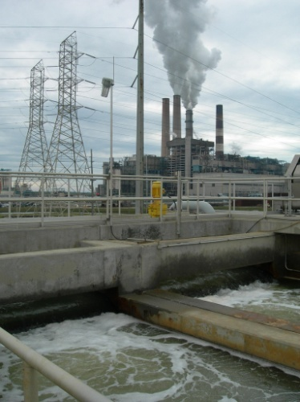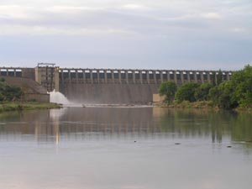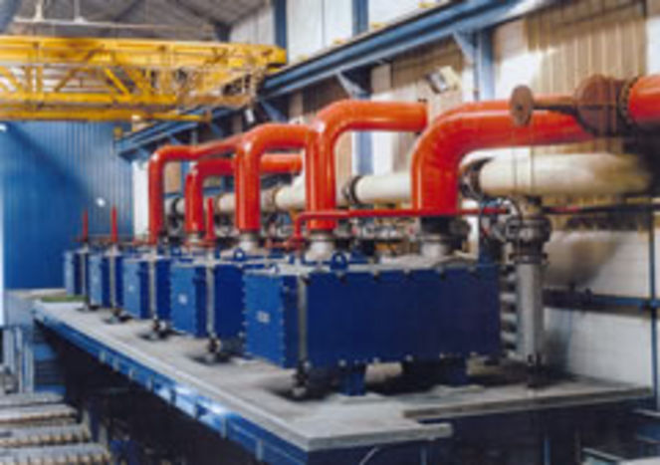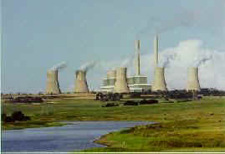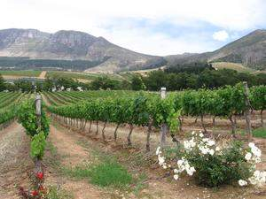

Project to Revise the Pricing Strategy for Water Use Charges and Develop a Funding Model for Water Infrastructure Development and Use and a Model for the Establishment of an Economic Regulator

Review of Raw Water Pricing Strategy - Discussion Document

February 2013 WP10465

 

Table of Contents

1 Introduction 2

1.1 Process to Date 2

1.2 Structure of the Discussion Document 2

2 Issues Requiring Policy Guidance 3

2.1 Principles of the Strategy 3

2.2 Objectives of the Strategy 4

2.3 Metering/Measuring Water Use 4

2.4 Managing Variable Water Use Levels 6

2.5 National, System or Scheme Charges 7

2.6 Addressing the Issue of Capping and Waiving of Charges 8

2.7 Return on Assets 11

2.7.1 Summary of approach to RoA 13

2.8 Waste Discharge Charge System (WDCS) 14

2.8.1 Mitigation Charge 15

2.8.2 Incentive Charge and the Money Bill 15

2.8.3 WDCS Roll Out 15

2.9 Hydropower 15

2.9.1 Hydropower in South Africa 16

2.9.2 Hydropower Water Use 16

2.9.3 Charging Hydropower Generators 17

2.10 Setting Multi-year Tariffs 17

3 Summary 17

4 Way Forward 18

4.1 Beyond the Discussion Document 19

# Introduction

The Department of Water Affairs (DWA) has put in place a process to review and, where necessary, amend the Raw Water Pricing Strategy.

Under the Pricing and Economic Regulator Review (PERR) project, an analysis has been conducted of the Raw Water Pricing Strategy to identify key gaps, challenges and issues that need to be addressed. This analysis was presented to the Pricing Strategy work-stream on 14th November 2012 for discussion. Arising from the analysis and the discussion at the work-stream meeting, this report captures the key issues pertaining to the revision of the Raw Water Pricing Strategy that need to be considered by DWA management in order to provide policy guidance on how to address the key issues.

This discussion document captures the key issues requiring consideration and deliberation. It is intended to provide input to the development of a draft raw water pricing strategy for consultation with sector stakeholders. It will serve primarily as a decision tool for the PSC and for DWA management. The decisions that are made on the basis of this discussion document will inform what amendments, and in what form, will be included in the draft raw water pricing strategy.

## Process to Date

As highlighted above, this discussion document is largely based on the Raw Water Pricing Strategy Gap Analysis, which itself was informed by a number of other documents that were prepared as part of the PERR project. The Gap Analysis aimed to identity the gaps and challenges that the pricing strategy stipulations pose to the water sector in South Africa so as to develop workable solutions to those challenges. This discussion document is the first step in developing those solutions that will form part of the revised raw water pricing strategy. The Gap Analysis was preceded by:

* A Pricing Strategy Review, an international review of water pricing and management – its aim was to survey the water resources policies and practises of other countries in order to draw out some relevant experiences and lessons
* No less than twelve meetings of the Project Steering Committee and the various work-streams.

The discussion document, has therefore, been drafted on the basis of the Pricing Strategy Review, the Gap Analysis and the captured discussions of the PSC and relevant work-stream meetings.

## Structure of the Discussion Document

The discussion document is divided into two sections.

* **Section 2**, which follows immediately after the introduction, outlines the various issues that need to be considered for decision and/or amendment. It outlines each issue, makes recommendations on how to address the issue and explores the pros and cons of each possible solution. On the basis of this assessment, it prioritises the possible responses in terms of optimal solutions.
* **Section 3** outlines the process going forward once the discussion document has been drafted.

# Issues Requiring Policy Guidance

The amendments required are to enhance the effectiveness of the raw water pricing strategy rather than to significantly change its fundamental aims and objectives, only to add important objectives that were previously omitted. The proposed amendments to the raw water pricing strategy are outlined in the following sections.

## Principles of the Strategy

There are four overarching principles that underpin the current raw water pricing strategy. These are social equity, ecological sustainability, financial sustainability and economic efficiency. These still hold true and remain relevant.

However, it would appear that there is a gap which could best be addressed by including a fifth principle in the pricing strategy: ***equitable economic development***. This would ensure that the pricing strategy is designed to support equitable economic development, which is different from economic efficiency as currently contained in the principles.

This fifth principle will serve to focus attention on how the pricing of water furthers the aims of developing and growing the economy for the benefit of all South Africans. Though the four principles thus far included address important aspects, none of them quite captures the importance of using water to ensure equitable economic development as part of the process of significantly reducing inequality in South Africa. This principle is clearly in line with national water policy and national government policy in general.

Over and above the addition of a fifth principle, the principles of the raw water pricing strategy need to be listed in the strategy in order of importance – from most important to least important. If this were done it would help guide decision making about raw water pricing from infrastructure development to emerging farmer support programmes. The recommended order of these principles would be as follows:

1. equitable economic development
2. social equity
3. ecological sustainability
4. financial sustainability, and
5. economic efficiency

This is not meant to compromise the attainment of any of these principles, only to guide decision making in cases where some of these principles may appear to clash.

***Recommendation: Inclusion of the principle of equitable economic development in the pricing strategy.***

***Recommendation: The Raw Water Pricing Strategy principles should be listed in order of national government priority***

## Objectives of the Strategy

The raw water pricing strategy outlines four distinct objectives which are all important for the sustainability of the water sector. The raw water pricing strategy objectives as currently outlined in the strategy are as follows:

* Funding water resources management by DWA and water management institutions through water use charges
* Funding water resource development and use of waterworks by DWA and water management institutions
* Achieving the equitable and efficient allocation of water through a charge hereafter referred to as the “economic charge”
* Providing for a differential rate for waste discharge, hereafter referred to as the WDCS

There is, however, a need for at least one more clearly outlined objective in order to ensure that all five principles and one of the key policy drivers of government are accounted for in what the raw water pricing strategy aims to achieve. These four objectives must be complemented by an additional objective which is the provision of financial assistance and the use of water pricing to support the redress of racial and gender imbalances in access to water and to support the redistribution of water for transformation and equity purposes.

The slow pace of redress in access to water and the low success rate of those who have benefited from land reform initiatives are of major concern in South Africa. Questions of land redress must necessarily be complemented by water use redress. In order for this redress to be successful, support must be extended to emerging Black farmers in every way possible. Incorporating redress into the raw water pricing strategy would mean that it would be possible to properly account for the level of government support provided for this purpose. At the same time, if correctly drafted, it would enable such support to be targeted at only those who need the support, avoiding an unnecessary ‘blanket’ approach.

In order to give full and proper effect to the objective of redress through the raw water pricing strategy, the objective must be properly defined and the manner in which it will be approached thoroughly detailed. The qualifying individuals must be defined, the level of support must be outlined and the final aim of the redress defined so as to have a clear goal for which to aim.

***Recommendation: Inclusion of an objective of: provision of financial assistance and the use of water pricing to support the redress of racial and gender imbalances in access to water and to support the redistribution of water for transformation and equity purposes***

## Metering/Measuring Water Use

Currently the manner in which water use charges are implemented provides a disincentive for un-metered water users to use water efficiently. The current charge calculation approach set out in the raw water pricing strategy is done by taking the total cost of activities and dividing it by the registered water use volumes or yield – the higher of the two – to arrive at a unit charge. The unit charge is then multiplied by each user’s *registered* water use volumes to arrive at the billed figure for each *unmetered* user – largely located in the irrigation sector. This approach incentivises the use of all registered water by irrigators and does not in any way incentivise water conservation or improved efficiency.

Ideally, water use should be billed against ***actual*** water use, rather than registered water use. This, however, requires the introduction of water metering/measuring across those water users that are currently unmetered. It is understood that there are regulations under development in DWA that will require compulsory metering/measuring by raw water users. In this regard, two issues need clarity:

* What are the time frames for promulgating the regulations and therefore what should be included in the Pricing Strategy with regard to using registered or actual volumes for charging, and
* Who will pay for the costs of the meters or measuring devices? If DWA is to pay for these, then the costs will need to be covered in some way. The question here is whether the costs will come from the fiscus or from water use charges, in which case it will need to be included in the Pricing Strategy. A combination of the fiscus and water use charges is also possible.

There is broad agreement within the South African water sector on the need to measure/meter water use. Metering/measuring water use is necessitated by a number of reasons, chief amongst which is the need to have an accurate account of the nation’s water resources and their use. Water metering/measuring would make it possible to develop a more accurate picture of the amount of water used across the country, how much is lost as a result of poor infrastructure or poor water management, and how much could be made available for redress initiatives.

There are, however, several challenges to water measuring/metering in the country. The challenges identified thus far include the type of infrastructure in some areas: some schemes were not built in a way that makes metering or measurement easy to do, which means some infrastructure upgrades will be necessary, posing an additional cost to get metering done. In addition, metering/measuring costs go beyond just the installation of the meters: there are meter operation and maintenance costs to be accounted for as well.

There are also some water use types that will prove difficult (though not impossible) to meter like the use of ground water through boreholes, though this does not account for the majority of water use. Ultimately, where boreholes are concerned, a cost-benefit analysis of metering the usage of borehole water would have to be conducted based on the amount of water abstracted through the borehole and the cost of meter installation, operation, maintenance and monitoring. A major question around the use of meters is the capacity of DWA and the water sector as a whole to manage the metering from installation, reading, maintenance and day-to-day operation.

In relation to the Pricing Strategy, the most critical question that needs to be addressed is who will pay for the installation, O&M and reading of the meters. DWA is currently in the process of developing water metering and measuring regulations which are intended to inform the approach to water metering and measurement, in consultation with all stakeholders. These regulations will also stipulate the responsibilities of various stakeholders in the process.

***Recommendation: Pricing strategy to allow for charging against registered water use until such time as metering/measuring is in place, in which case metered/measured volumes will be used;***

***Recommendation: Payment for installation of meters and/or measuring devices, O&M and checking of meters and accuracy of reporting to be charged for under the Pricing Strategy as part of the infrastructure charge***

## Managing Variable Water Use Levels

One of the challenges of the Pricing Strategy is ensuring sufficient revenue to cover the relevant costs and to address charging for water use according to transparent business principles. Ensuring sufficient revenue can be impacted by annual fluctuations in water use both in metered water areas and by irrigated agriculture in drought conditions. This potential for annual fluctuations will increase as increasing areas of irrigation are charged on the basis of actual water use, rather than registered water use. Water use is strongly influenced by rainfall: when rains are good, water use may decrease in the irrigation sector, while, at the same time, water use may decrease in particularly dry seasons due to shortages of water. It is not possible to predict, in advance, what the actual water use is going to be, particularly in the irrigation sector. What makes this particularly challenging is the fixed nature of the majority of water infrastructure related costs that must be covered despite the fluctuations in water use.

In the period between 2002 and today, DWA only received one request for relief of water levies as a result of drought. However, this has been a period of relatively good rains. The financial implications of such a request are twofold. On the one hand there is a loss of revenue for DWA as a result of reductions in tariffs as per the guidelines of the current pricing strategy. On the other hand there is an actual cost to DWA due to the relief subsidies extended to affected users for their schemes to ensure that maintenance of the infrastructure. In the case of the cited request, the total financial implication was R29 987 428.48 for just one water management area (WMA). Even if this were assumed to be the annual cost of drought support, the addition per m3 cost of this to users would be less than 1 cent annually given the current registered volumes. Reduction in revenue from municipal water users arising from drought conditions is not recorded but impacts on revenue to DWA.

If all WMAs were to be hit by droughts at the same time, revenue loss could conceivably run into the billions. Some measures must be put in place to ensure that such a situation can be mitigated if it were to ever occur. In this case, one approach may be to approach Treasury to cover the shortfall. However, the approach chosen for the collection of revenue to be used in the event of droughts must inform how much is collected for the purposes of a drought time reserve and inform the rules around when drawdowns from this reserve can happen. This also serves to re-emphasize the importance of ring-fencing this reserve.

In addition to normal fluctuations in water use, the current system allows for substantial reductions in charges where drought results in curtailments of water use to below 70% of registered water use. Equally, municipal curtailment of water use due to drought may severely impact on the revenue due to DWA. However, there is no clarity on how the income shortfall arising from this is to be addressed – is this shortfall to be recovered from the fiscus, or are the water charges to be calculated in a manner that will cover this potential shortfall over a period of time? Under the current approach, although the WRM costs are covered during a drought, funding for infrastructure maintenance can be compromised depending on the extent and duration of the drought.

The need to cover the fixed costs of water management and infrastructure management regardless of water use levels cannot be ignored. For this reason, an approach that achieves both objectives (water use efficiency and covering of fixed costs) must be designed.

Addressing the potential fluctuations in water use and hence in annual revenue is best addressed by adopting an approach that incorporates assurance of supply into the annual charges, so that the annual charge takes into account the likelihood of reduced water use/revenue. This would translate into a small percentage being added to annual charges to cover those years in which there may be reduced water use.

The advantage of incorporating “drought time” costs is that water infrastructure can always be maintained regardless of the level of tariff income that is generated during droughts or low water use periods. Incorporating lost revenue costs into the overall charges would also align with the principle of user pays.

An alternative approach would be to ensure that any revenue lost through the implementation of drought rules would be recovered from the fiscus. This would require an agreement with National Treasury on this matter, and would require post hoc recovery of the funds through Treasury, once the extent of the loss in each year is known. This approach is not recommended as it has higher risks in terms of the availability of funding from Treasury, and has high transaction costs in terms of the application to Treasury

***Recommendation: A percentage, calculated on assurance of supply, to be added to infrastructure charges to enable DWA to cover the costs of revenue losses during drought periods and period of reduced water use;***

## National, System or Scheme Charges

The question has been raised as to whether there should be one national charge for raw water use, along the lines of the Eskom tariff. There are two other approaches that can also be considered, one being the current scheme-based approach, and the other being the possibility of using system based charges.

In this regard, some analysis has already been done on the relative merits of the three approaches to setting tariffs: national, system or scheme, as contained in the detailed report on the Pricing Strategy Gap Analysis.

One of the concerns driving the thinking behind a national tariff is that water users on new water schemes pay much higher water tariffs/charges than those drawing water from older schemes. In the light of the fact that many of the older schemes have served primarily white users, this is seen as contributing to the equity challenges in the water sector. However, a number of issues must be taken into account when considering the shape of the tariff structure:

* A national tariff will result in cross-subsidisation between a number of schemes, However, if it is a blanket national scheme it may result in poor water users cross-subsidising expensive water systems (such as the Vaal river system), not only in wealthier water users subsidising poorer users. An examination of the current tariffs shows that many rural schemes are paying below the national average tariff and would see significant price hikes as a result of a national tariff. Equally, of course, there are many schemes that would see a decrease in charges as a result of a national tariff;
* Water is provided on a disaggregated basis, not through a national grid as is the case with electricity. The reason for charging costs related to specific schemes or systems is that these charges reflect the real cost of the water, thus driving appropriate decisions relating to efficiency of water use. Charging a national tariff will lose correlation between the tariff and the actual cost of water provided in a particular locality, with the potential for inappropriate water use decisions. This approach goes against international best practice in which water charges reflect the actual cost of water in a particular area.
* At the same time, there are schemes currently under development, such as de Hoop, where the cost of water is exorbitantly high, and an approach must be adopted that will make this water affordable to poor users in particular.

In this regard, targeted subsidies are considered the most appropriate approach, and are dealt with in the following section.

Rather than adopting a national tariff, it is worth considering a ***scheme based tariff*** system, where an average tariff is charged for water use from an inter-connected infrastructure, such as the Western Cape system that serves the City of Cape Town. In such an approach, all users that draw water from an inter-connected system would pay the same charge in terms of both the infrastructure and WRM charges.

A system-based approach has a number of benefits, which include the potential to allocate new infrastructure costs against the whole system, rather than to the new users only. This has important equity dimensions, since most of the older, and cheaper, schemes benefit the earlier water users, who are primarily white. The systems based approach will, in many cases, enable new schemes that will benefit new users to be carried by all the users in a system rather than only the users of the new scheme, thus reducing the costs to the new users.

The system-based approach also recognises the inter-connected nature of South African water resources, and responds to this inter-connectedness through the pricing strategy.

There are, however, some challenges attached to the move to a system-based approach. The first challenge is the need to define the systems that one would be charging against. This will require some work, and as a result it is recommended that an incremental approach be adopted, phasing in the system-based approach over several years across the country.

***Recommendation: The introduction of a system based charging system phased in over several years***

## Addressing the Issue of Capping and Waiving of Charges

The raw water pricing strategy as it stands stipulates the capping of certain charges for the agriculture and forestry sectors. In particular, agriculture does not pay the RoA, while forestry does not pay certain elements of the WRM charge (water quality). While the latter amounts to a relatively small sum, the former has considerable impact.

Table 1 below indicates the revenue loss in 2012/13 due to the caps and waivers of charges related to the RoA, depreciation and O&M. The latter two result from the capping on increases on charges on a year to year basis, while the former results from the decision not to charge the RoA to the irrigation sector. This table does not indicate loss of revenue arising from reduced charges to resource poor farmers or revenue lost as a result of drought rules being implemented.

Table 1: Revenue loss due to capping and waiver of charges (2012/13)

|  |  |  |  |  |
| --- | --- | --- | --- | --- |
| **FINANCIAL YEAR 2012/13** | |  |  |  |
|  | **FULL COST ESTIMATED REVENUE** | | |  |
|  | **ROA** | **DEPR** | **O+M** | **TOTAL** |
| Central Operation | 315,732,257 | 37,860,820 | 53,542,457 | 407,135,534 |
| Northern Operation | 416,985,818 | 131,035,751 | 273,793,468 | 821,815,037 |
| Eastern Operation | 41,423,000 | 4,088,620 | 41,084,865 | 86,596,485 |
| Southern Operation | 408,420,063 | 32,750,506 | 61,178,804 | 502,349,374 |
| **TOTAL** | **1,182,561,138** | **205,735,697** | **429,599,595** | **1,817,896,429** |
|  |  |  |  |  |
|  | **CAPPED ESTIMATED REVENUE** | | |  |
|  | **ROA** | **DEPR** | **O+M** | **TOTAL** |
| Central Operation | 0 | 21,139,640 | 47,652,183 | 68,791,823 |
| Northern Operation | 0 | 55,715,657 | 123,004,185 | 178,719,842 |
| Eastern Operation | 0 | 3,637,144 | 30,817,899 | 34,455,043 |
| Southern Operation | 0 | 17,525,225 | 47,175,530 | 64,700,754 |
| **TOTAL** | **0** | **98,017,666** | **248,649,797** | **346,667,462** |
|  |  |  |  |  |
|  | **REVENUE LOSS DUE TO CAPPING** | | |  |
|  | **ROA** | **DEPR** | **O+M** | **TOTAL** |
| Central Operation | 315,732,257 | 16,721,180 | 5,890,274 | 338,343,710 |
| Northern Operation | 416,985,818 | 75,320,093 | 150,789,284 | 643,095,195 |
| Eastern Operation | 41,423,000 | 451,476 | 10,266,966 | 52,141,442 |
| Southern Operation | 408,420,063 | 15,225,282 | 14,003,275 | 437,648,620 |
| **TOTAL** | **1,182,561,138** | **107,718,031** | **180,949,798** | **1,471,228,967** |

This section deals only with the caps on the depreciation and O&M charges, and not with the RoA which is dealt with in the following section.

While described as caps, the limitations on increasing the charges for depreciation and O&M effectively result in subsidies being provided to these sectors as they are being charged below actual costs, and the shortfall must be recovered from some other source. Currently this shortfall is covered by the fiscus, although it is not addressed as a transparent subsidy of the irrigation and forestry sectors, and it is not clearly calculated and budgeted for under the national budget vote.

The caps have been in place for some time, despite no rationale being provided in the current strategy for their existence. Their use is broad and has no specific justification or stated goal, and it is unclear to what extent all or any of the beneficiaries need these subsidies. One of the challenges of the capping approach is that it applies to all users in a particular sector, regardless of their financial position, resulting in subsidies being given to users that might not require subsidisation. On the other hand, it is easier to apply than a more targeted subsidy might be.

Currently, for example, the industry-wide price caps subsidise the production of products grown for export purposes, and it must be questioned whether this should be the aim of the raw water pricing strategy. If so, this should presumably be guided by economic policy, not water policy.

There is, thus, a need for a combined approach from DWA, Department of Trade and Industry (DTI), (Economic Development Department (EDD) and Department of Agriculture, Forestry and Fisheries (DAFF) that determines to what extent the water costs of the irrigation and forestry sectors should be subsidised and to what end. This will ensure more targeted, effective and measurable support to the agricultural sector that achieves the aims of ensuring food security, land and water use. The question must also be discussed between these departments as to whether subsidies should be provided through the Raw Water Pricing Strategy, or more directly by DAFF. It can be argued that if farmers require subsidies to remain viable, that this function should be performed by DAFF, and that providing below-cost water to farmers and the forestry sector sends an inappropriate signal regarding water use in a water scarce country.

The obvious advantage of reviewing the use of caps to effectively extend subsidies to the agricultural and forestry sectors is that of ensuring the most effective use of fiscal funds. For example, subsidising crops that are not critical for food security is effectively subsidising the profits of private farmers – using of public funds to ensure private profits. It does also, support agricultural jobs. The government, more broadly than DWA, must decide if this is an approach they wish to adopt, or whether they only wish to subsidise specific crops such as those supporting food security.

If this latter approach is to be adopted, some discussion and/or research will need to be done to determine what crops are critical for food security in South Africa and to what extent those who farm those crops must be supported if they are unable to maintain profitability, albeit with a pre-determined level of efficient use of resources.

Independently from this, subsidies can and should also be extended to emerging black farmers to help them establish viable agricultural entities as part of the land and agrarian reform programme of government.

There is potential risk in withdrawing support from farmers of crops that are not critical for food security. Farm labour is usually the only source of employment in rural South Africa so if enough farms were to stop operations there could be a massive impact on rural livelihoods. A review of farm viability must be conducted and weighed against the risk of job losses. There is also the challenge of losing foreign exchange earnings which are important for the economy at large. The more export oriented farming entities contribute to foreign exchange earnings so stopping production in those farms could have economy wide impacts. What is important is to determine if these farming entities need the support in order for them to be viable. If not, it should be withdrawn. The government’s limited resources must be deployed in the most effective ways possible. However, as mentioned above, the decision to subsidise farming operations because of these concerns should be driven by DAFF, and not by DWA.

Currently, the caps indirectly serve as protection for water users in that they ensure that DWA, catchment management agencies (CMAs) and other water management institutions (WMIs) cannot increase their charges beyond the caps. If the caps are to be removed, a protection regime must be put in place for water users to ensure that WMIs don’t see this as a licence to add to their cost base. A combination of consultation and efficiency measures must be developed as a method of accountability. Equally, it must be recognised that current water resources management charges are below the appropriate level to cover the costs of water resources management. The proposed economic regulator will be critical in ensuring that there is not over or under-charging on water use charges.

A concern relating to the use of the pricing strategy for what would effectively be targeted subsidization is the potential contravention of the regulations of the General Agreement on Trade and Tariffs (GATT) or the World Trade Organisation’s (WTO) definition of prohibited subsidies. However, a reading of what the WTO defines as prohibited subsidies – “subsidies that require recipients to meet certain export targets, or to use domestic goods instead of imported goods . . . (subsidies that) are specifically designed to distort international trade, and are therefore likely to hurt other countries’ trade”[1] – suggests that the approach prescribed would be unlikely to contravene the WTO regulations. Due to the fact that no tariffs would be getting levied on imported goods or services in anyway, the GATT regulations are irrelevant in this case.

The use of subsidies to strengthen the economic position of formerly excluded members of society falls more in the ambit of social intervention than trade distortion, and is a necessary social intervention for ethical, security and developmental purposes.

***Recommendation: Change from capping of depreciation and O&M charges to particular sectors to targeted subsidies to particular categories of users within those sectors;***

***Action needed: DWA to organise discussion with DAFF, EDD, DTI and NT on what subsidies should be provided, to whom, and through what mechanisms.***

## Return on Assets

Currently the National Water Act allows for the charging of a Return on Assets (ROA) element in the raw water pricing strategy. ‘Return on Assets’ is generally viewed as a private sector term with very specific implications in terms of meaning and practical application. ROA as a tool is meant to give an idea as to how efficient management is at using its assets to generate earnings, and profit in particular. It is likely that if ROA as a term was to be properly applied in the public sector its measurement would include more elements than just income generated directly from the users of those assets, for example growth in the economy/sector, tax generated from the sector etc. Using this term to name an element of the water charges does not properly describe what the charge is intended for. A more suitable name that properly expresses the intended use of the revenue generated from the collection of that charge should be developed and legislated.

In addition, the purpose of the ROA and how it is to be calculated need to be addressed. Currently, the ROA is intended to fund future on-budget infrastructure development, and it has been calculated on the basis of a predicted 4% increase in water demand translated into a 4% ROA.

There are several issues that arise regarding the charging of RoA:

* There is a policy question to be addressed as to whether it is appropriate for current water users to fund future water developments (the issue of intergenerational equity), or whether such infrastructure should be funded from the fiscus;
* There is no rationale behind the translation of a 4% increase in water demand into a 4% ROA, and there is little evidence that the 4% bears any direct relation to the actual costs that need to be funded. It is proposed instead to develop a methodology that aligns the ROA with actual costs that must be funded;
* There is no clarity on the actual financial requirements of future developments that are to be funded through the ROA and over what period – this is necessary to support the calculation of the charge;
* The ROA is not charged on off-budget schemes until such time as the loan has been paid off, at which point a reduced ROA is planned to be charged to users[2]. There is a concern that this amounts to double charging these users who are currently paying the full costs of the infrastructure that is developed to serve them, and who will pay any further developments through off-budget financing;
* The ROA is charged on all water use by municipalities, despite a portion of that water being provided to serve basic human needs. The equitable share does not cover the capital costs of water resources infrastructure, but only O&M costs of water services infrastructure.

According to the current pricing strategy, the RoA reflects payment towards the development and betterment capital value of waterworks on government water schemes that are to be funded on-budget. This excludes the costs of all off-budget schemes that will be paid for through a scheme based CUC. If this remains the purpose of the ROA charge, as it should, it makes more sense to calculate the charge based on the estimated/planned infrastructure spend using a ten year rolling cycle to be reviewed annually. However, there must be some checks and balances put in place to ensure that this charge does not rise to unacceptable levels, as well as a mechanism to ensure that funds not spent are used to mitigate future ROA charge increases.

The estimated/planned infrastructure spend over the next ten years is R79.025 billion (an average of R7.902 billion per annum). The registered water volumes for government water schemes, excluding off-budget funded schemes, is 7.9 billion m3 per annum. The registered water use for domestic and industrial users (including power generation and mining) is 2.8 bn m3. The table below reflects the average RoA charge if 100%, 75%, 50% or 25% of the total infrastructure spend is taken as the proportion of the total infrastructure spend that will be funded on budget.

Table 2: Average RoA for different % of proposed infrastructure investment funded on-budget

|  |  |  |  |  |
| --- | --- | --- | --- | --- |
| Assumption | **100% on-budget** | **75% on-budget** | **50% on-budget** | **25% on-budget** |
| Estimated national WR infrastructure spend 2013-2023 | R 79 025 000 000 | R 59 268 750 000 | R 39 512 500 000 | R 19 756 250 000 |
| Estimated Annual National WR Infrastructure Spend between 2012 and 2023 | R 7 902 500 000 | R 5 926 875 000 | R 3 951 250 000 | R 1 975 625 000 |
| Total registered water use on government water schemes (m3) | 8 798 150 873 |  |  |  |
| Registered water use excluding off-budget schemes (m3) | 7 918 335 786 |  |  |  |
| Domestic and Industrial Registered Water Use(m3) | 2 846 867 309 |  |  |  |
| Annual ROA calculated on Total Registered Water (R/m3) | R 0.898 | R 0.674 | R 0.449 | R 0.225 |
| Annual ROA excluding current off-budget schemes (R.m3) | R 0.998 | R 0.749 | R 0.499 | R 0.250 |
| Annual ROA calculated on Domestic and Industrial Water Use only (R/m3) | R 2.776 | R 2.082 | R 1.388 | R 0.694 |

From this, is can be seen that, assuming that only domestic and industrial users will pay the RoA, as is currently the case, the average RoA will range from 69c/m3 to R2.70/m3. This is a substantial increase from the current average per m3 charge of 12.6c/m3. Taking the proposed approach would result in a substantial tariff increase for domestic and industrial users. Should the RoA be spread across irrigation users as well, the charge reduces substantially.

The argument has previously been made that agriculture should not pay the RoA charge as they will not benefit from any future infrastructure development, since future infrastructure development will result in water that is too expensive for agricultural purposes. If this argument is still supported, then the RoA should only be paid by domestic and industrial users, and will see a considerable increase. The removal of the ROA charge exemption from agriculture would have a significant impact on farming costs. However, it must be noted that agriculture itself benefits from infrastructure funded by past generations.

From these calculations, it would appear that only a portion of the capital costs of future social infrastructure can be borne by current water users, and that the remaining portion of the costs should come from the fiscus. A mechanism for determining this proportion must be developed.

### Summary of approach to RoA

There are three different aspects to infrastructure that should be separated out:

* **Economic infrastructure**: Economically viable infrastructure, which should be funded off-budget and paid through the CUC;
* **Basic Human Needs WR Infrastructure** which in its entirety or partially provides water for basic human needs. This should not attract RoA charges as it is inappropriate to ask the poor to pay for future infrastructure development on the back of basic human needs. This amount should be covered by the state through the fiscus. This aspect of the costs of basic water supply is not covered by the Equitable Share or MIG, and should be explicitly dealt with in the pricing strategy.
* **Developmental infrastructure** which is infrastructure that is being provided to support poverty eradication and economic development and which is ***initially*** not financially viable but which is intended to support economic growth and development in a particular area. In such as case, the RoA could be waived for a period of, say, 10 years, for resource poor users, and brought in incrementally over 5 years after that. This would enable resource poor water users to have a window period for development of their business, after which time they would start paying the RoA. This approach could also be used for new, resource poor and historically disadvantaged users of existing infrastructure.

***Policy question: Should current water users fund future social water infrastructure development through a charge on current water use or should this be funded from the fiscus?***

***Recommendation: No RoA to be charged on the basic human needs portion of water provided to municipalities with these amounts to be covered by the fiscus instead;***

***Recommendation: RoA to be charged on all existing on-budget funded schemes that serve commercial water users***

***Recommendation: RoA to be waived for 10 years and then to be introduced incrementally over five years after the construction of new social infrastructure / infrastructure intended for developmental purposes.***

***Recommendation: RoA not to be charged on off-budget schemes once the CUC has been paid off, as any future developments serving those water users will be paid for through a CUC again.***

***Recommendation: RoA to be calculated on the basis of planned future spend for on-budget schemes, with an agreed proportion of this future spend to come from the fiscus to ensure affordability of the RoA charge.***

## Waste Discharge Charge System (WDCS)

Even with the national water quality challenges being identified and comprehensive policy and management frameworks being formulated as early as the early 1990’s, there has continued to be widespread water quality deterioration in many of the South Africa’s key catchments. In an attempt to mitigate this, the National Water Act of 1998 enables the Minister to establish a Pricing Strategy for charges on water use that may (Section 26) provide for a differential rate for waste discharges.

The waste discharge charge system has been developed around the polluter pays principle and the adoption of economic instruments and aims to:

* promote the sustainable development and efficient use of water resources,
* promote the internalisation of environmental costs by polluters,
* create financial incentives for dischargers to reduce waste and use water resources in a more optimal way,
* recover costs associated with mitigating water quality impacts of waste discharge.

The charge should aim to create a win-win situation wherein economic and environmental forces combine towards sustainable development, by providing an incentive for moving towards the efficient use and reuse of water.

### Mitigation Charge

The mitigation charge is related to the recovery of costs associated with mitigation and abatement measures employed in the water resource to achieve Raw Water Quality Objectives (RWQOs). It must be focused on the recovery and disbursement of quantifiable costs incurred in the mitigation of direct impacts of waste discharge. In order to be a user charge, it is important that dischargers only pay according to their proportional contribution to the problem. Accordingly, while the Mitigation Charge may influence dischargers to reduce their discharge loads, it must be defined around the cost of mitigation.

### Incentive Charge and the Money Bill

One of the charges proposed in the WDCS is the Incentive charge aimed at ensuring the optimal use of the resource for discharging or disposal of waste. It is therefore based on charging for the use of the resource rather than directly on recovering costs. Section 57(5) prohibits any charge that is established under the National Water Act from being “of such a nature as to constitute the imposition of a tax, duty or levy”. Taxes, levies or duties are considered to be payments that are not proportional to services received in return. The Incentive Charge is defined to affect discharge behaviour, rather than recover costs and, therefore, constitutes an environmental tax. This authority is the sole preserve of the Minister of Finance through the promulgation of a Money Bill, which is only valid for 5 years, after which it must be tabled again.

### WDCS Roll Out

The WDCS project is being piloted on 3 catchments. Once the pilot phase is complete, the process of identifying priority catchments for the implementation of the WDCS begins with an assessment of the water quality problem. The WDCS is applied only where RWQOs are exceeded or threatened. In the absence of RWQOs, a clear water quality problem must exist within a catchment/area for consideration as a priority catchment for implementation of the WDCS. Initial prioritisation will be done as part of the WDCS Implementation Strategy.

There will be a stand-alone chapter in the pricing strategy that will better define and describe the details of the WDCS.

***Recommendation: Interact with the WDCS strategy under development to input into the process and determine how it aligns with the pricing strategy***

## Hydropower

Hydropower accounts for about 16% of the world’s electricity supply[3]. Due to the fact that its proponents regard hydropower as a comparatively clean, low-cost and renewable form of energy, it is likely to have an increased share of the electricity supply in future. South Africa would also like to increase the amount of hydropower generated in the country following electricity outages of the recent past, which has implications for water use patterns. A charge that reflects the impact of hydropower on water use must be developed and put in place.

### Hydropower in South Africa

South Africa currently has a mix of small hydroelectricity stations and pumped water storage schemes. In the latter, water is pumped up to a reservoir during off-peak energy periods. During peak hours, when extra electricity is needed, the water is released through a turbine that drives an electric generator.

There is potential for the development of further small hydropower plants in South Africa with capacities ranging from 1 megawatt (MW) to 15 MW, generating approximately 446 000 MWh/annum.

The National Water Act (NWA) defines as one of the water uses the “disposing in any manner of water which contains waste from, or which has been heated in, any industrial or power generation process”. It also gives the Minister the power “to regulate activities having a detrimental impact on water resources by declaring them to be controlled activities” and goes on to define one of these controlled activities as the “altering the flow regime of a water resource as a result of power generation”. However, the current pricing strategy does not include amongst its various water charges a hydropower generation charge. The hydropower charge is important to separate because of the unique characteristics of the water use of the process.

### Hydropower Water Use

Some view hydropower only as an in-stream water user. However, there are reports that provide scientific support for the argument that hydroelectric generation is, in most cases, a significant water consumer. Most of the water consumed during hydropower generation is a result of evaporation during the process.

A study of 35 hydropower sites representing only 8% of the global installed hydroelectric capacity showed that the amount of water lost through evaporation annually at these 35 sites is equivalent to 10% of the global blue water footprint related to crop production. It also found that the water footprint of hydroelectricity is largely influenced by the area flooded per unit of installed capacity. The water footprint linearly increases with the area flooded per unit of installed capacity[4].

A second way in which hydropower impacts water use is that it alters the water release pattern from dams. Hydropower generation can require the release of water from dams during times that downstream water users do not require the water, while restricting the flow of water during times that downstream water users need the water. This can have a significant impact on farming activities that could alter the productivity of the land. In cases when water is being released specifically and solely for the purposes of hydropower generation, this should be considered as water use/consumption. Even though the process does not itself consume the water, the release of water that would otherwise have been available for other activities is equivalent to the consumption of that water. The key is to differentiate between water that is release during periods that other water users also need the water and periods when it is released when no downstream users need the water.

### Charging Hydropower Generators

There is no question that hydropower generators derive benefit from water resource infrastructure and should therefore be charged in one way or another for the development, operation, maintenance, refurbishment and betterment of that infrastructure. However, given the unique manner in which hydropower generation uses and/or impacts water, careful consideration must be given to the design of the charges they pay.

There are two ways in which hydropower can be considered to be using water – the evaporation that results from generation and release of water during periods that no-one else needs it downstream. These could be calculated and used as the amount of registered water use volumes that hydropower stations then get all the pricing strategy water charges levied on them: the sum of out of irrigation season water releases and evaporated water figures. This is an extremely complex and difficult approach to take.

An alternative and simpler approach to charging hydropower stations for their water use is to charge them a charge based on c/kWh (cent per kilowatt hour) of energy generated and a fixed charge based on kW installed, instead of the cent per cubic meter of water use charged for raw water abstraction, which is neither practical nor applicable.

***Recommendation: Hydropower users to be charged a*** ***c/kWh (cent per kilowatt hour) of energy generated and a fixed charge based on kW installed Introducing multi-year charges***

## Setting Multi-year Tariffs

Currently the water resources charges are calculated on an annual basis, with annual engagements with stakeholders on the proposed amendments. In order to facilitate improved forward planning by water users, DWA and CMAs, it is proposed that a multi-year charge setting process be introduced that will set a determined charge for year one and indicative tariffs for years two and three. This will enable DWA, CMAs and water users to engage more constructively with future plans and to understand the future likely implications for charges.

***Recommendation: The pricing strategy should introduce a multi-year charge setting process, covering at least a three year rolling period***

# Summary

The diagram below outlines the critical differences between the current pricing strategy and the proposed pricing strategy as recommended in this discussion document.

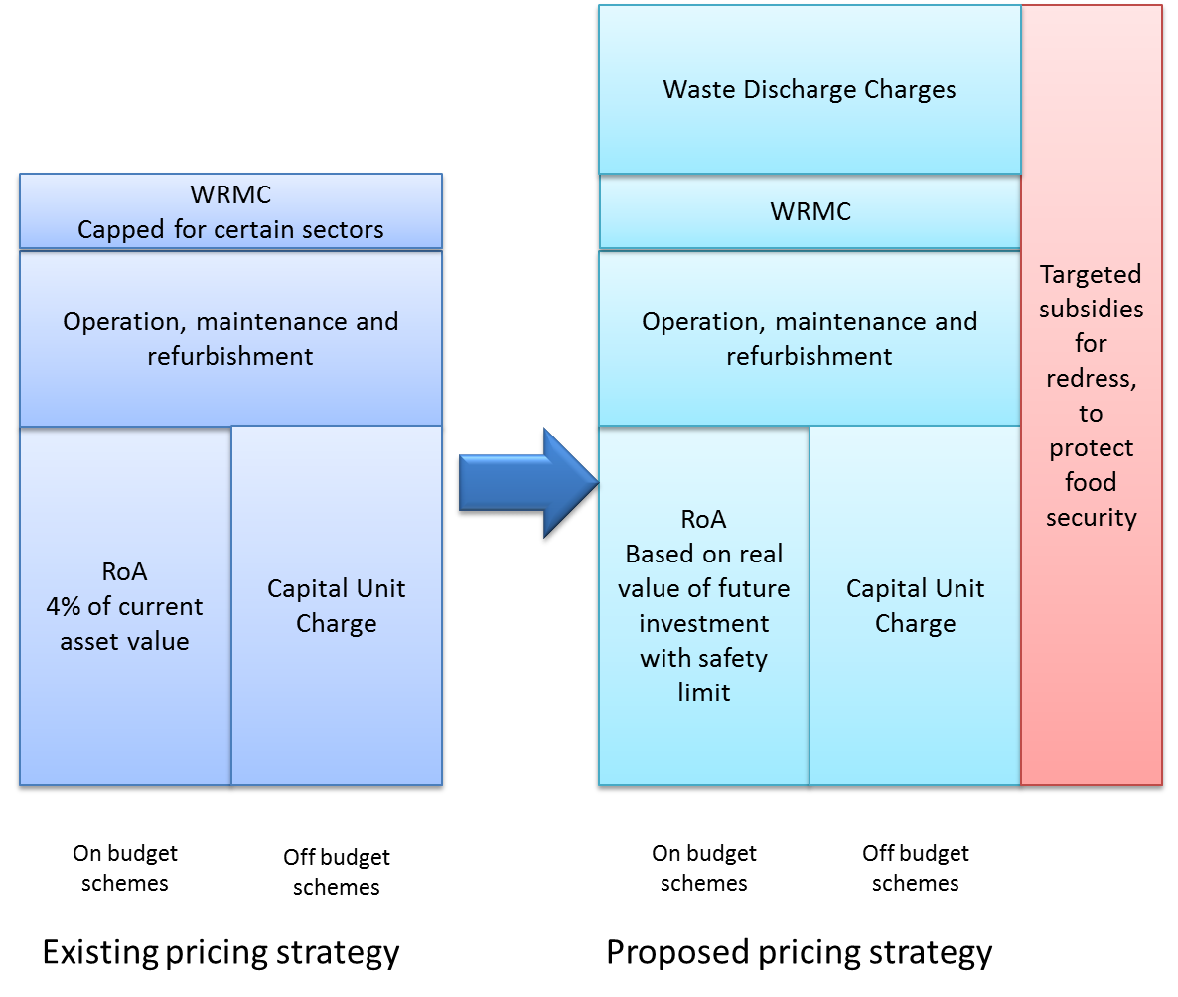

# Way Forward

There is a target to deliver a draft raw water pricing strategy by 31 March 2013 that will be ready for consultation with stakeholders.

This discussion document was drafted to ensure that there can be a comprehensive process of internal consultation within DWA, and that consultation within the work-streams and with certain key stakeholders can occur before the draft raw water pricing strategy is published for comment. In so doing, the aim is to develop a draft raw water pricing strategy that presents a single recommendation on the resolution of each challenge identified in the current raw water pricing strategy. These single recommendations to the challenges would then be presented to the public for consultation.

This is likely to be an option that will lead to a speedier resolution of the finalised draft of the raw water pricing strategy because of the focussed discussions that will result from having single recommendations for each identified challenge. The consultation process can still be as robust, but it would be more focused. It does mean, however, that internal DWA consultation and consultation with key stakeholders will need to take place in February 2013 and that the PSC will need to provide clear guidance on the issues outlined in this document by the end of February so that a coherent draft strategy can be delivered by the end of March 2013.

## Beyond the Discussion Document

The first step that must follow the completion of this discussion document must be broadly distributing it within DWA, PSC members and work-stream members so as to permit a period of consideration and input. Once distributed, the discussion document must be discussed at the various meetings of the work-streams and PSC, followed by a period of incorporation of comments.

Once all the comments have been taken into consideration, the drafting of the raw water pricing strategy including all the agreed upon recommendations for each of the identified challenges must be completed. The draft needs to be completed with enough time to permit those who gave input into the discussion document time to review the draft raw water pricing strategy before it is put in the public domain for broader consultation. This will ensure that all stakeholders in the process are able to speak with one voice when public consultations take place, fully understanding the contents and implications of the positions put forward in the draft raw water pricing strategy.

Once the draft raw water pricing strategy reaches the public consultations process, redrafting will only take place at the end of this process to incorporate any agreed upon changes that emanate from this process. Once all comments are reviewed and incorporated, the final raw water pricing strategy with be developed and handed over to DWA.

It must be noted that some assessment must be done of the cost implications of the new proposals for water users, and where there are likely to be significant changes, a high level cost benefit analysis must be conducted to understand the impact on particular sectors. This will need to accompany the draft strategy so that stakeholders can be reassured that DWA has addressed these issues to the best extent possible.

1. <http://www.wto.org/english/thewto_e/whatis_e/tif_e/agrm8_e.htm#subsidies>, accessed 6 January 2013.
2. This will not happen for over a decade due to the time frames for the payment of loans on existing off-budget schemes
3. M.M. Mekonnen and A.Y. Hoekstra, 2011, The Water Footprint of Electricity from Hydropower
4. M.M. Mekonnen and A.Y. Hoekstra, 2011, The Water Footprint of Electricity from Hydropower